SJ Guillaume
Professor Jumadinova
Computer Science 110
08 December 2014

Final Report

My motivation for this project began over Thanksgiving break. I was sitting with my family when we were trying to decide on which movie to watch. I come from a family of four children and then my mom and dad so there was a lot of input of different ideas for the movie. Of course, I claimed we needed a more fair system of choosing a movie since we didn't choose the one I wanted to watch. After this, I made the joke that I was going to write a program to make a program that will choose a movie fairly for us. This program is useful to solve the problem of choosing a movie whether you need it to solve a conflict of interest, or just have no idea what to watch.
The program I created is called Movie Magic. It operates by using a main method and three other classes as well as 10 text files. How it works is: The main method prints a welcome message and asks the user if he wants to choose a genre or have a random genre chosen for him. The MainMovie scans the number of the choice that the user inputs and enters an if/else loop where if the user chose “1” it will take him into the MovieChoices class and go to method chooseGenre(). If the user inputs “2” the program will go into the chooseRandom() method in the MovieChoices class. For chooseGenre() the method asks the user for the number of the genre he wishes to have a movie selected from. The answer is scanned in and the program goes into an if/else statement. It goes through and uses “==” to compare the number the user entered to the number that corresponds to the number assigned to different genres. For example, if the user entered 2 because they want a movie/movies from the Classic category it will go through the if/else statements until it gets to (choice == 2). In the chooseRandom() method, the movie category is selected randomly through a random number generator which will choose a number between 0 and 9 since it uses the .nextInt(10) method of the Random Class. If the random number generator chose the number two by chance, it would go through the if/else statements until it got to “num == 2”, this functions similarly to the chooseGenre() method mentioned above. In both methods of the MovieChoices class, once the genre assignment is found, the if else statement then calls the MovieList class and goes into the method of the movie genre it is intended to locate. For example, for the Classic movie genre both in chooseGenre() and chooseRandom(), the list calls movieList.Classic(). The program goes into movieList.Classic and asks the user if he wants a single random movie selection, a list of 10 movies from that genre, or the entire list of movies of that genre that Movie Magic has stored. The user's answer is scanned in and assigned as the value of a variable. Then the program goes into an if/else statement where if the number was 1, the program goes into the MovieGenre() class and method for the specific genre. If the user enters the number 2 for a list of 10 movies, a for loop is used to call movieGenre.Classic() 10 times and increment the count so that it exits before entering the 11th loop. If the user entered the number 3 the program uses a while loop to print all the movies through the movieGenre.Classic() method. In the MovieGenre class, there is a method for each genre which reads in all the movies in a corresponding text file to an Array list. The method then creates an integer called size and assigns its value as the size of the Array list. To get a random movie, the random integer method is used and the result of that is assigned to the integer “randnum” which is then the number corresponding to a movie in the Array list which is then printed as the result.

Example:
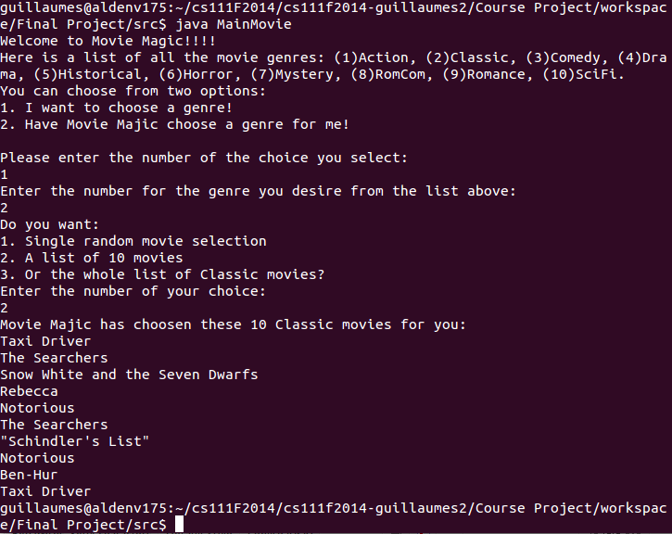
In this example we can see how we begin in the main method MainMovie.java and then go into the MovieChoices class and the chooseGenre() method within that class. The choose Genre class takes the user's input for the Classic Genre when he enters the number 2. In that method it goes to the ifelse statement that corresponds to the Classic Genre. The program then enters MovieList in the Classic() method and the user chooses to print a list of 10 movies. For a list of 10 movies it goes into the ifelse statement using a while loop and goes into the MovieGenre class and Classic() method in that class 10 times.
This lab worked very well in the end, it produces the output that I have intended it to. It will produce a single title, a list of ten, or the entire list of a certain genre which you can either choose yourself, or have the program choose for you. I learned a lot about constructing classes and using different types of loops and if/else statements. The hardest part of this lab was organizing it efficiently. I think I got it to be as streamlined as I could, but I am sure there are ways it could be better. The biggest reward was when after creating and implementing all the classes, I actually got it to run. If it didn't run, I think I would have been lost because it had to go through so many classes to get to the class and method that would produce the desired output.

